**Data Warehouse Concepts**

The basic concept of a Data Warehouse is to facilitate a single version of truth for a company for decision making and forecasting. A Data warehouse is an information system that contains historical and commutative data from single or multiple sources. Data Warehouse Concepts simplify the reporting and analysis process of organizations.

## Characteristics of Data warehouse

Data Warehouse Concepts have following characteristics:

* Subject-Oriented
* Integrated
* Time-variant
* Non-volatile

### Subject-Oriented

A data warehouse is subject oriented as it offers information regarding a theme instead of companies' ongoing operations. These subjects can be sales, marketing, distributions, etc.

A data warehouse never focuses on the ongoing operations. Instead, it put emphasis on modeling and analysis of data for **decision making**. It also provides a simple and concise view around the specific subject by excluding data which not helpful to support the decision process.

### Integrated

In Data Warehouse, integration means the establishment of a common unit of measure for all similar data from the dissimilar database. The data also needs to be stored in the Datawarehouse in common and universally acceptable manner.

A data warehouse is developed by integrating data from varied sources like a mainframe, relational databases, flat files, etc. Moreover, it must keep consistent naming conventions, format, and coding.

This integration helps in effective analysis of data. Consistency in naming conventions, attribute measures, encoding structure etc. have to be ensured. Consider the following example:

[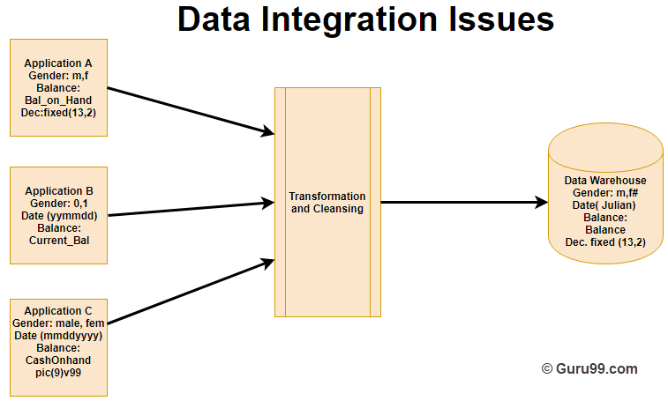](https://www.guru99.com/images/1/022218_0735_DataWarehou1.png)

In the above example, there are three different application labeled A, B and C. Information stored in these applications are Gender, Date, and Balance. However, each application's data is stored different way.

* In Application A gender field store logical values like M or F
* In Application B gender field is a numerical value,
* In Application C application, gender field stored in the form of a character value.
* Same is the case with Date and balance

However, after transformation and cleaning process all this data is stored in common format in the Data Warehouse.

### Time-Variant

The time horizon for data warehouse is quite extensive compared with operational systems. The data collected in a data warehouse is recognized with a particular period and offers information from the historical point of view. It contains an element of time, explicitly or implicitly.

One such place where Data warehouse data display time variance is in in the structure of the record key. Every primary key contained with the DW should have either implicitly or explicitly an element of time. Like the day, week month, etc.

Another aspect of time variance is that once data is inserted in the warehouse, it can't be updated or changed.

### Non-volatile

Data warehouse is also non-volatile means the previous data is not erased when new data is entered in it.

Data is read-only and periodically refreshed. This also helps to analyze historical data and understand what & when happened. It does not require transaction process, recovery and concurrency control mechanisms.

Activities like delete, update, and insert which are performed in an operational application environment are omitted in Data warehouse environment. Only two types of data operations performed in the Data Warehousing are

1. Data loading
2. Data access

Here, are some major differences between Application and Data Warehouse

|  |  |
| --- | --- |
| **Operational Application** | **Data Warehouse** |
| Complex program must be coded to make sure that data upgrade processes maintain high integrity of the final product. | This kind of issues does not happen because data update is not performed. |
| Data is placed in a normalized form to ensure minimal redundancy. | Data is not stored in normalized form. |
| Technology needed to support issues of transactions, data recovery, rollback, and resolution as its deadlock is quite complex. | It offers relative simplicity in technology. |

**Data Warehouse Architecture**

**Data Warehouse Architecture** is complex as it’s an information system that contains historical and commutative data from multiple sources. There are 3 approaches for constructing Data Warehouse layers: Single Tier, Two tier and Three tier. This 3 tier architecture of Data Warehouse is explained as below.

**Single-tier architecture**

The objective of a single layer is to minimize the amount of data stored. This goal is to remove data redundancy. This architecture is not frequently used in practice.

**Two-tier architecture**

Two-layer architecture is one of the Data Warehouse layers which separates physically available sources and data warehouse. This architecture is not expandable and also not supporting a large number of end-users. It also has connectivity problems because of network limitations.

**Three-Tier Data Warehouse Architecture**

This is the most widely used Architecture of Data Warehouse.

It consists of the Top, Middle and Bottom Tier.

1. **Bottom Tier:** The database of the Datawarehouse servers as the bottom tier. It is usually a relational database system. Data is cleansed, transformed, and loaded into this layer using back-end tools.
2. **Middle Tier:**The middle tier in Data warehouse is an OLAP server which is implemented using either ROLAP or MOLAP model. For a user, this application tier presents an abstracted view of the database. This layer also acts as a mediator between the end-user and the database.
3. **Top-Tier:**The top tier is a front-end client layer. Top tier is the tools and API that you connect and get data out from the data warehouse. It could be Query tools, reporting tools, managed query tools, Analysis tools and Data mining tools.